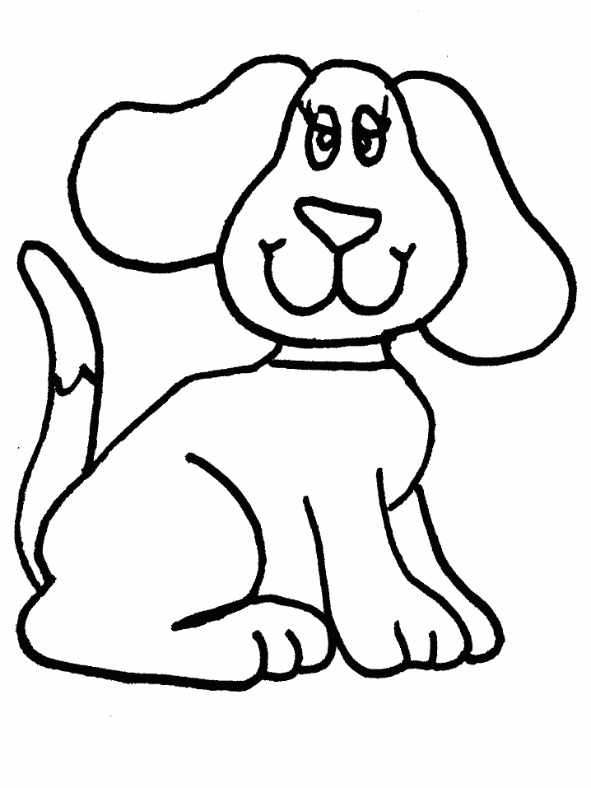 KA + + NÍK = ______________

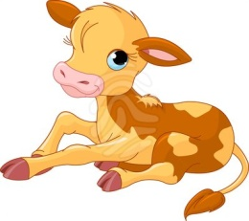

+VIZE = __________________

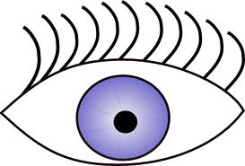

L+ +MOTIVA =______________

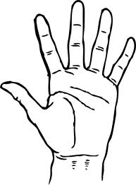

+VICE =_________________



PAMPE+ = ____________

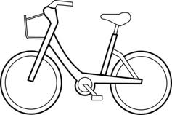

+BĚŽKA= _______________

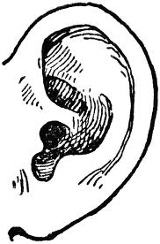

+PIT = _______________

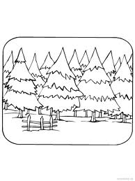

+NÍK = ______________

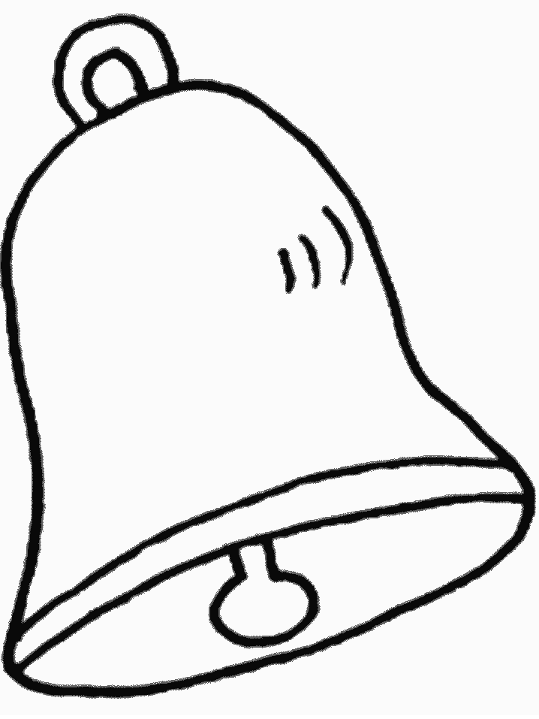-K + ČEK = __________

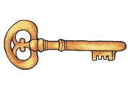

PETR + =____________



* ENKA + LE = __________

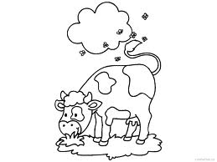

+ FON = _______________

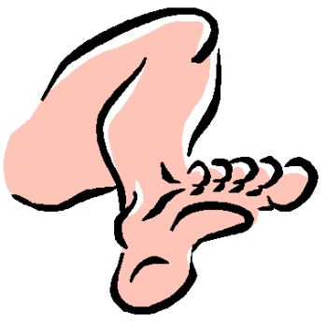

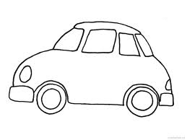 + VICE = _____________

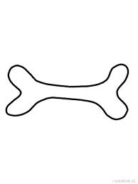 + BUS = _____________

+ IČKA= ____________

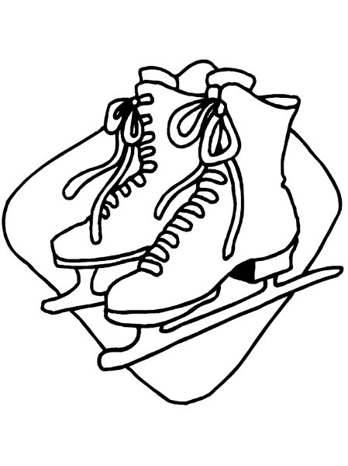

* BRU + PICE = _________